## Related image

**SPRING/SUMMER MENU**

|  |  |  |  |  |  |
| --- | --- | --- | --- | --- | --- |
| **WEEK 1** | **Monday** | **Tuesday** | **Wednesday** | **Thursday** | **Friday** |
| **MORNING SNACK** | **Rice Chex &**  **Oranges/Mandarins**  Water  (Inf) Milk | **Blackberries &**  **WW Soda Crackers**  Water  (Inf) Milk | **Bananas & Veggie Brenton Bites**  Milk | **Apple Sauce & Cheddar Cheese**  Water  (Inf) Milk | **Homemade Blueberry Chia Spread on WW Bagels**  Water  (Inf) Milk |
| LUNCH | **Veggie Quesadillas & Carrots** | **Chicken Korma Rice & Sweet Peas** | **Spaghetti & Meatballs with Broccoli** | **Spinach Mushroom Quiche with Green Beans** | **Breaded Fish, Potatoes & Carrots** |
| Proteins | Veggie Ground | Chicken | Beef | Egg | Pollock |
| **Vegetables** | Spinach, Mushrooms, Onions, Celery  Baby Carrots  (Inf/T) Cooked Carrots | Sweet Peas, Corn, Onion, Tomato | Green Peppers, Mushrooms, Tomatoes, Onions, Broccoli | Spinach, Mushrooms, Red/Green Peppers, Onions, Green Beans | Potatoes, Carrots |
| **Bread/Grains** | WW Tortillas | 7 Grain Rice Blend  WW Dinner Rolls | Whole Grain Pasta  WW Bread | WW Bread | Whole Grain Bread |
| **Fruit** | Pineapple | Sliced Cantaloupe | Nectarines/Peaches | Mango | Kiwi |
| **Dairy** | Marble Cheese  Milk | Yogurt  Milk | Milk | Cheddar Cheese  Milk | Milk |
| **AFTERNOON SNACK** | **Pears**  **Pita bites**  (Inf) Breton crackers  Milk | **Strawberries**  **Arrowroot cookies**  Milk | **Spinach dip**  **Soda crackers**  Water | **Avocado**  **Multigrain Thin Buns**  Water | **Apples**  **Sweet potato crackers**  **(Inf) Avocado**  Milk |

## Related imageSPRING/SUMMER MENU

|  |  |  |  |  |  |
| --- | --- | --- | --- | --- | --- |
| **WEEK 2** | **Monday** | **Tuesday** | **Wednesday** | **Thursday** | **Friday** |
| **MORNING SNACK** | **Multi-Grain Cheerios**  **& Pineapple**  Water  (Inf) Milk | **Fresh Strawberries &**  **Tofutti**  **on Rice Cakes**  Milk | **Fresh Blackberries & Soy Butter**  **on Graham Wafers**  Water  ( Inf) Milk | **Kiwi &**  **Sweet Potato Crackers**  (Inf) **Veggie Breton**  **Crackers**  Milk | **Fresh Pears**  **&**  **Arrowroot Cookies**  Water  (Inf) Milk |
| LUNCH | **Tuna Salad Sandwiches with**  **Carrots & Cucumbers** | **Veggie Falafels &**  **Quinoa-Rice with Green Peas** | **Homemade Macaroni**  **&**  **Lentil Cheese Sauce with Broccoli** | **Chicken Veggie**  **Stir-fry**  **& Rice** | **Cheddar Cheeseburgers**  **with**  **Carrots & Cucumbers** |
| **Proteins** | Tuna | Chick Peas, Quinoa | Nutritional Yeast, Cheddar Cheese, Lentils | Chicken | Lean Beef |
| **Vegetables** | Sliced Cucumbers,  Baby Carrots  (Inf/T) Cooked Carrots | Green Peas | Broccoli | (Sweet Peppers, Mushrooms, Zucchini, Carrots, Bean Sprouts,  Broccoli, Onions) | Cucumbers  Baby Carrots  (I/T) Cooked Carrots  Sliced Dill Pickles |
| **Bread/Grains** | Whole Wheat Bread | Quinoa-Brown Rice  WW Tortillas | Whole Grain  Elbow Pasta  Whole Grain Bread | Brown Rice  Whole Wheat Bread | Multigrain Thin Buns |
| **Fruit** | Orange Pinwheels  (Inf) Mandarins | Cantaloupe Wedges | Fresh Nectarines/ Peaches | Bananas | Sliced Honey Dew |
| **Dairy** | Milk. | Milk | Milk | Milk | Cheddar Cheese  Milk |
| **AFTERNOON SNACK** | **Raspberries in**  **Vanilla Yogurt with Hemp Hearts &**  **WW Soda Crackers**  Water | **Roasted Red Pepper Hummus**  **on Multigrain**  **Thin Buns**  Water | **Watermelon**  **&**  **Digestive Cookies**  Milk | **Homemade**  **Mango Chia**  **on**  **Pita Bread**  Water | **Cheddar Cheese**  **& Sliced Apples**  **WW Soda Crackers**  (Inf) **Applesauce**  Water |

## Related imageSPRING/SUMMER MENU

|  |  |  |  |  |  |
| --- | --- | --- | --- | --- | --- |
| **WEEK 3** | **Monday** | **Tuesday** | **Wednesday** | **Thursday** | **Friday** |
| **MORNING SNACK** | **Multi-Grain Cheerios**  **&** **Orange Slices**  (Inf) **Mandarins**  Water  (Inf) Milk | **Fresh Blackberries & Graham Wafers**  Water  (Inf) Milk | **Bananas**  **&**  **Rice Chex**  Milk | **Mango Chia & WW Soda Crackers**  Water  (Inf) Milk | **Fresh Nectarines/Peaches**  **&**  **Life Multigrain Cereal**  Milk |
| LUNCH | **Hiker’s**  **Minestrone Soup** | **Chicken Fajita** Casserole | **Egg Salad Sandwiches**  **with Carrots & Cucumbers** | **Cabbage Roll Casserole**  **& Broccoli** | **Vegetarian**  **Sloppy Joes**  **& Green Beans** |
| Proteins | Black Beans,  Kidney Beans  & Chick Peas | Chicken | Egg | Lean Ground Beef | Veggie Ground |
| **Vegetables** | (Beans, Diced Tomatoes, Carrots, Peas, Gr. Beans, Corn, Onions) | (  (Sweet Peppers, Peas, Tomatoes, Carrots Corn & Avocados) | Cucumbers &  Baby Carrots  (Inf/T) Cooked Carrots | (Diced Tomatoes,  Spinach, Orange Peppers, Mushrooms, Onions)  with Broccoli | (Diced Tomatoes, Tomato Sauce, Spinach, Carrots, Mushrooms, Sweet Peppers, Onions)  with Green Beans |
| **Bread/Grains** | Fusilli Pasta  WW Soda Crackers | Brown Rice  Whole Wheat  Tortilla Quarters | Whole Grain Bread | Whole Wheat Bread | WW English Muffins |
| **Fruit** | Apple Sauce | Sliced Cantaloupe | Sliced Watermelon | Sliced Honey Dew | Sliced Kiwi |
| **Dairy** | Milk | Marble Cheese  Milk | Milk | Milk | Mozzarella Cheese  Milk |
| **AFTERNOON SNACK** | **Fresh**  **Strawberries & Oatmeal Cookies**  Milk | **Blueberries in Vanilla Yogurt**  **with Hemp Hearts**  **& Arrowroots**  Water | **Sw. Peppers & Spinach Dip with Pita Bites**  (Inf) Whole **Grain Snackbread**    Water | **Cheddar Cheese**  **Apple Slices &**  **Sweet Potato Crackers**  **(Inf) Apple Sauce**  **&Veggie Bretons**  Water | **Sliced Cucumbers**  **& Tuna Salad on**  **Multigrain Thin Buns**  Water |

## SPRING/SUMMER MENU Related image

|  |  |  |  |  |  |
| --- | --- | --- | --- | --- | --- |
| **WEEK 4** | **Monday** | **Tuesday** | **Wednesday** | **Thursday** | **Friday** |
| **MORNING SNACK** | **Pineapple &**  **Rice Chex**  Water  (Inf) Milk | **Apple Sauce & Graham Wafers**  Water  (Inf) Milk | **Daiya Cream cheese**  **on WW Soda Crackers**  **Mango**  Water  (Inf) Milk | **Sliced Kiwi &**  **Digestive Cookies**  Water  (Inf) Milk | **Fresh Pears &**  **Multi-Grain Cheerios**  Water  (Inf) Milk |
| LUNCH | **Chicken Salad Sandwiches**  **& Carrots** | **Teriyaki Beef**  **with Rice**  **& Green Beans** | **Spaghetti &**  **Veggie Meatballs**  **& Broccoli** | **White Bean Curry** | **Breaded Fish Fillets with Potatoes, Peas**  **& Carrots** |
| **Proteins** | Chicken | Lean Ground Beef | Veggie Meatballs  (Soy Protein) | White Beans | Pollock |
| **Vegetables** | Sliced Cucumbers  with Baby Carrots  (Inf/T) Cooked Carrots | (Red/Gr, Peppers, Broccoli, Carrots, Mushrooms, Onions)  with Green Beans | (Green/Red Peppers,  Diced Tomatoes, Tomato Sauce, Mushrooms, Onions)  with Broccoli | (Celery, Carrots, Onions, Spinach) | Potatoes, Cooked Carrots &  Sweet Peas |
| **Bread/Grains** | Whole Wheat Bread | Brown Rice  Whole Grain Bread | Whole Grain Spaghetti  Whole Wheat Bread | Corn Rice Blend  WW Dinner Rolls | Whole Grain Bread |
| **Fruit** | Orange Pinwheels  (Inf) Mandarins | Sliced Cantaloupe | Fresh Nectarines/ Peaches | Bananas | Watermelon |
| **Dairy** | Milk | Milk | Milk | Marble Cheese  Milk | Milk |
| **AFTERNOON SNACK** | **Fresh Strawberries**  **&**  **Arrowroot Cookies**    Milk | **Avocado**  **&**  **Whole Grain**  **Thin Buns**  Water | **Cheddar Cheese**  **Sliced Apples**  **&**  **WG Snack bread**  (Inf) **Applesauce**  Water | **Blueberries in**  **Vanilla Yogurt**  **with Hemp Hearts**  **& Veggie Breton Bites**  Water | **Chick Pea Hummus**  **& Pita Bites**  **(Inf) Vinta Crackers**  Milk |

## Related image

**SPRING/SUMMER MENU**

|  |  |  |  |  |  |
| --- | --- | --- | --- | --- | --- |
| **WEEK 5** | **Monday** | **Tuesday** | **Wednesday** | **Thursday** | **Friday** |
| **MORNING SNACK** | **Multi-Grain Cheerios**  **& Orange Pinwheels**  Water  (Inf) **Mandarins** Milk | **Sliced Kiwi &**  **Arrowroots**  Water  (Inf) Milk | **Bananas**  **&**  **Life Multigrain**  Milk | **Sliced Apples &**  **Cheddar Cheese**  (Inf) **Applesauce**  Water | **Pineapple**  **&** **Sweet Potato Crackers**  Water  (Inf) **WG Snack bread**  (Inf) Milk |
| LUNCH | **Veggie Chili** | **Asian Chicken**  **Rice Bowls** | **Beef Kheema**  **with** **Rice** | **Fish Cakes**  **with**  **Mashed**  **Sweet Potato Blend** | **Grilled Cheese & Chick Pea Salad** |
| Proteins | Black Beans. Veggie Ground Soy Protein | Chicken | Lean Ground Beef | Tuna | Chick Peas  & Cheese |
| **Vegetables** | (Mixed Vegetables, Chopped Tomatoes, Onions) | (Red/Green Peppers, Broccoli, Carrots, Mushrooms) | (Diced Tomatoes, Mixed Peppers,  Peas, Onions) | (Blended White & Sweet Potatoes)  with Peas | (Chick Peas & Broccoli) |
| **Bread/Grains** | Wh. Gr. Rotini Pasta  WW Dinner Rolls | 7 Grain Rice Blend  Whole Grain Bread | Brown Rice  Whole Wheat Bread | Whole Grain Bread | Whole Wheat Bread |
| **Fruit** | Applesauce | Cantaloupe Wedges | Sliced Honeydew | Sliced Watermelon | Fresh Peaches/Nectarines |
| **Dairy** | Marble Cheese  Milk | Milk | Milk | Milk | Mozzarella Cheese  Milk |
| **AFTERNOON**  **SNACK** | **Raspberries**  **in Vanilla Yogurt**  **with Hemp Hearts**  **Oatmeal Cookies**  Water | **Fresh Strawberries & Veggie Bretons**  Milk | **Sweet Potato Hummus**  **with Multigrain**  **Thin Buns**  Water | **Orange/Yellow Peppers**  **Ranch Dip &**  **WW Soda Crackers**  (Inf) **Avocado**    Water | **Fresh Pears**  **&**  **Daiya Cream Cheese on Rice Cakes**  Milk |

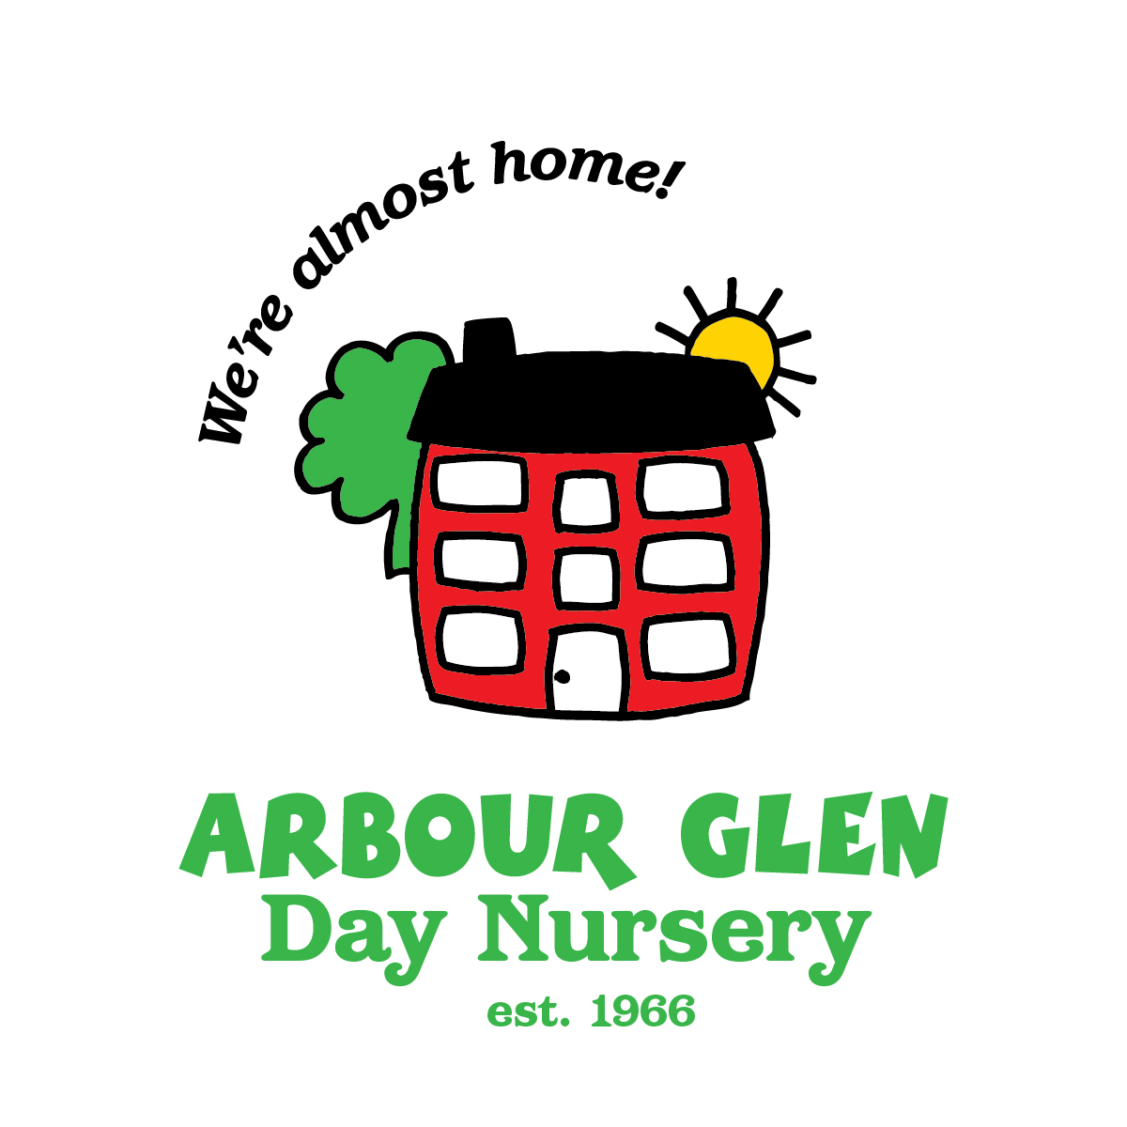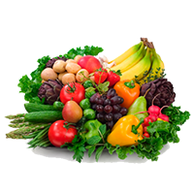

## 

|  |  |  |  |  |  |
| --- | --- | --- | --- | --- | --- |
| WEEK 6 | Monday | Tuesday | Wednesday | Thursday | Friday |
| **MORNING SNACK** | Life  Multi-Grain Cereal & Pineapple  Water  (Inf) Milk | Fresh Blackberries  & Rice Cakes with  Daiya Cream Cheese  Water  (Inf) Milk | Bananas  & Rice Chex  Water  (Inf) Milk | Homemade Blueberry  Chia Spread on  Pita  Water  (Inf) Milk | Sweet Potato Hummus & WW Soda Crackers  Water  (Inf) Milk |
| LUNCH | Tuna Twisters with Carrots & Cucumbers | Plant-based Cheeseburgers & Broccoli | Beef Cabbage  Stir-fry with Noodles | Spinach-Cheese with Tofu Pizza & Green Beans and Carrots | Chicken Cacciatore |
| Protein | Tuna, Cheddar Cheese | Soy Protein, Beans | Lean Ground Beef | Cheese | Chicken |
| **Vegetables** | Cucumbers  & Baby Carrots  (Inf./T) Cooked Carrots | Broccoli  & Dill Pickles | (Cabbage, Carrots Peppers, Onion) | (Tomato Sauce, Spinach)  with Cucumbers  & Baby Carrots  (Inf/T) Cooked Carrots | (Tomatoes, Cucumbers, Peas, Carrots, Onion) |
| **Fruit** | Oranges  (Inf) Mandarins | Cantaloupe Wedges | Nectarines | Mango | Sliced Kiwi |
| **Bread/Grains** | WW Tortillas | WW Hamburg Buns | Whole Grain Linguine  Whole Grain Bread | Pizza Shells | Whole Grain  Fusilli Pasta  Whole Grain Rolls |
| **Dairy** | Shredded Marble Cheese  Milk | Cheddar Cheese  Milk | Milk | Mozzarella &  Cheddar Cheeses  Milk | Marble Cheese  Milk |
| **AFTERNOON SNACK** | **Fresh Strawberries**  **& Arrowroot Cookies**  Milk | **Raspberries in Yogurt with Hemp Hearts & Graham Wafers**  Water | **Apple Slices &**  **Cheddar Cheese**  **WW Soda Crackers**  (Inf) **Applesauce**  Water | **Watermelon-Cucumber Salad,**  **Sweet Potato Crackers**  (Inf) **Veggie Breton**  Milk | **Fresh Pears &**  **Multi-Grain Cheerios**    Milk |

## SPRING/SUMMER MENU