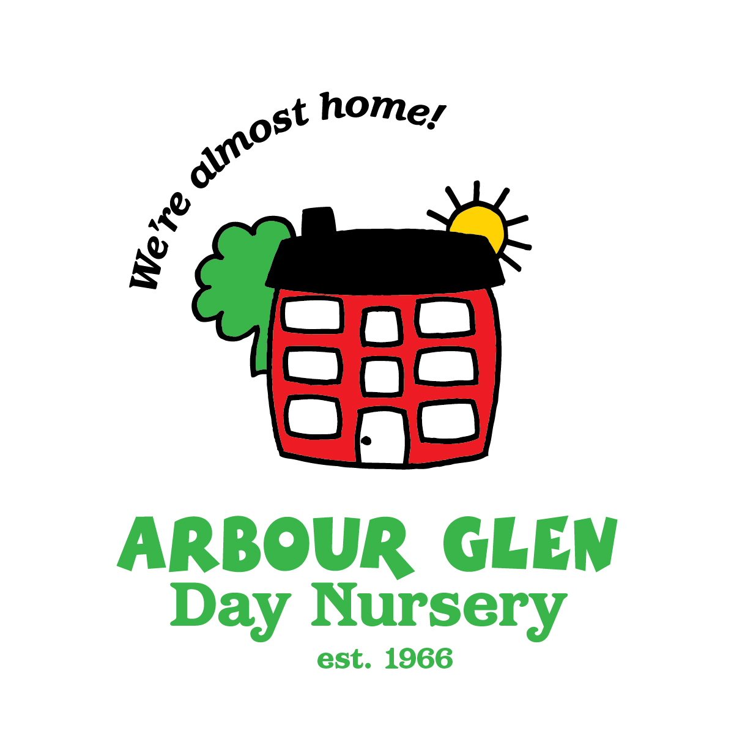 SPRING/SUMMER MENU 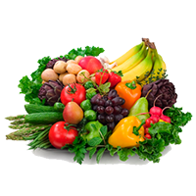
WEEK 1 | Monday | Tuesday | Wednesday | Thursday | Friday
MORNING SNACK | Rice Chex &  Oranges/Mandarins  Water  (Inf) Milk | Blackberries &  WW Soda Crackers  Water  (Inf) Milk | Bananas & Veggie Brenton Bites  Milk | Apple Sauce & Cheddar Cheese  Water  (Inf) Milk | Homemade Blueberry Chia Spread on WW English Muffins  Water  (Inf) Milk
LUNCH | Corn Salad Wraps & Carrots | Chicken Korma Rice & Sweet Peas | Spaghetti & Meatballs with Broccoli | Spinach Mushroom Quiche with Green Beans | Breaded Fish, Potatoes & Carrots
Proteins | Chickpeas | Chicken | Beef | Egg | Pollock Fish
Vegetables | Corn, Spinach Cucumbers,  Baby Carrots  (Inf/T) Cooked Carrots | Sweet Peas, Corn, Onion, Tomato | Green Peppers, Mushrooms, Tomatoes, Onions, Broccoli | Spinach, Mushrooms, Red/Green Peppers, Onions, Green Beans | Potatoes, Carrots
Bread/Grains | WW Tortillas | 7 Grain Rice Blend  WW Dinner Rolls | Whole Grain Pasta  WW Bread | WW Bread | Whole Grain Bread
Fruit | Pineapple | Sliced Cantaloupe | Nectarines/Peaches | Mango | Kiwi
Dairy | Marble Cheese  Milk | Yogurt  Milk | Milk | Cheddar Cheese  Milk | Milk
AFTERNOON SNACK | Blackberries  Pita bites  (Inf) Breton crackers  Milk | Strawberries  Arrowroot cookies  Milk | Spinach dip  Soda crackers  Water | Avocado  Multigrain Thin Buns  Water | Apples  Sweet potato crackers  (Inf) Avocado  Milk

SPRING/SUMMER MENU
WEEK 2 | Monday | Tuesday | Wednesday | Thursday | Friday
MORNING SNACK | Multi-Grain Cheerios  & Pineapple  Water  (Inf) Milk | Fresh Strawberries &  Tofutti  on Rice Cakes  Milk | Fresh Blackberries & Soy Butter  on Graham Wafers  Water  ( Inf) Milk | Kiwi &  Beetroot Crackers  (Inf) Veggie Breton  Crackers  Milk | Fresh Pears  &  Arrowroot Cookies  Water  (Inf) Milk
LUNCH | Tuna Salad Sandwiches with  Carrots & Cucumbers | Veggie Falafels &  Quinoa-Rice with Green Peas | Homemade Macaroni  &  Lentil Cheese Sauce with Broccoli | Chicken Veggie  Stir-fry  & Rice | Cheddar Cheeseburgers  with  Carrots & Cucumbers
Proteins | Tuna | Chick Peas, Quinoa | Nutritional Yeast, Cheddar Cheese, Lentils | Chicken | Lean Beef
Vegetables | Sliced Cucumbers,  Baby Carrots  (Inf/T) Cooked Carrots | Green Peas | Broccoli | (Sweet Peppers, Mushrooms, Zucchini, Carrots, Bean Sprouts,  Broccoli, Onions) | Cucumbers  Baby Carrots  (I/T) Cooked Carrots  Sliced Dill Pickles
Bread/Grains | Whole Wheat Bread | Quinoa-Brown Rice  WW Tortillas | Whole Grain  Elbow Pasta  Whole Grain Bread | Brown Rice  Whole Wheat Bread | Multigrain Thin Buns
Fruit | Orange Pinwheels  (Inf) Mandarins | Cantaloupe Wedges | Fresh Nectarines/ Peaches | Bananas | Sliced Honey Dew
Dairy | Milk. | Milk | Milk | Milk | Cheddar Cheese  Milk
AFTERNOON SNACK | Raspberries in  Vanilla Yogurt with Hemp Hearts &  WW Soda Crackers  Water | Roasted Red Pepper Hummus  on Multigrain  Thin Buns  Water | Watermelon  &  Digestive Cookies  Milk | Homemade  Mango Salsa  on  WW English Muffins  Water | Cheddar Cheese  & Sliced Apples  WW Soda Crackers  (Inf) Applesauce  Water

SPRING/SUMMER MENU
WEEK 3 | Monday | Tuesday | Wednesday | Thursday | Friday
MORNING SNACK | Multi-Grain Cheerios  & Orange Slices  (Inf) Mandarins  Water  (Inf) Milk | Fresh Blackberries & Graham Wafers  Water  (Inf) Milk | Bananas  &  Rice Chex  Milk | Homemade  Mango Salsa & WW Soda Crackers  Water  (Inf) Milk | Fresh Nectarines/Peaches  &  Life Multigrain Cereal  Milk
LUNCH | Hiker’s  Minestrone Soup | Chicken Fajita Casserole | Egg Salad Sandwiches  with Carrots & Cucumbers | Lasagne Casserole  & Broccoli | Vegetarian  Sloppy Joes  & Green Beans
Proteins | Black Beans,  Kidney Beans  & Chick Peas | Chicken | Egg | Lean Ground Beef | Veggie Ground
Vegetables | (Beans, Diced Tomatoes, Carrots, Peas, Gr. Beans, Corn, Onions) | (  (Sweet Peppers, Peas, Tomatoes, Carrots Corn & Avocados) | Cucumbers &  Baby Carrots  (Inf/T) Cooked Carrots | (Diced Tomatoes,  Tom. Sauce, Spinach, Orange Peppers, Mushrooms, Onions)  with Broccoli | (Diced Tomatoes, Tomato Sauce, Spinach, Carrots, Mushrooms, Sweet Peppers, Onions)  with Green Beans
Bread/Grains | Fusilli Pasta  WW Soda Crackers | Brown Rice  Whole Wheat  Tortilla Quarters | Whole Grain Bread | Whole Wheat Bread | WW English Muffins
Fruit | Apple Sauce | Sliced Cantaloupe | Sliced Watermelon | Sliced Honey Dew | Sliced Kiwi
Dairy | Milk | Marble Cheese  Milk | Milk | Ricotta, Mozzarella, Cottage Cheese  Milk | Mozzarella Cheese  Milk
AFTERNOON SNACK | Fresh  Strawberries & Oatmeal Cookies  Milk | Blueberries in Vanilla Yogurt  with Hemp Hearts  & Arrowroots  Water | Sw. Peppers & Spinach Dip with Pita Bites  (Inf) Whole Grain Snackbread  Water | Cheddar Cheese  Apple Slices &  Beetroot Crackers  (Inf) Apple Sauce  &Veggie Bretons  Water | Sliced Cucumbers  & Tuna Salad on  Multigrain Thin Buns  Water

SPRING/SUMMER MENU
WEEK 4 | Monday | Tuesday | Wednesday | Thursday | Friday
MORNING SNACK | Pineapple &  Rice Chex  Water  (Inf) Milk | Apple Sauce & Graham Wafers  Water  (Inf) Milk | Tofutti  on WW Soda Crackers  Mango  Water  (Inf) Milk | Sliced Kiwi &  Digestive Cookies  Water  (Inf) Milk | Fresh Pears &  Multi-Grain Cheerios  Water  (Inf) Milk
LUNCH | Chicken Salad Sandwiches  & Carrots | Teriyaki Beef  with Rice  & Green Beans | Spaghetti &  Veggie Meatballs  & Broccoli | Chick Pea Pasta Salad | Breaded Fish Fillets with Potatoes, Peas  & Carrots
Proteins | Chicken | Lean Ground Beef | Veggie Meatballs  (Soy Protein) | Chick Peas | Pollock Fish
Vegetables | Sliced Cucumbers  with Baby Carrots  (Inf/T)Cooked Carrots | (Red/Gr, Peppers, Broccoli, Carrots, Mushrooms, Onions)  with Green Beans | (Green/Red Peppers,  Diced Tomatoes, Tomato Sauce, Mushrooms, Onions)  with Broccoli | (Chopped Tomato,  Orange Peppers, Carrots, Cucumber, Onion) | Potatoes, Cooked Carrots &  Sweet Peas
Bread/Grains | Whole Wheat Bread | Brown Rice  Whole Grain Bread | Whole Grain Spaghetti  Whole Wheat Bread | Whole Grain Fusilli Pasta  WW Dinner Rolls | Whole Grain Bread
Fruit | Orange Pinwheels  (Inf) Mandarins | Sliced Cantaloupe | Fresh Nectarines/ Peaches | Bananas | Watermelon
Dairy | Milk | Milk | Milk | Marble Cheese  Milk | Milk
AFTERNOON SNACK | Fresh Strawberries  &  Arrowroot Cookies  Milk | Avocado  &  Whole Grain  Thin Buns  Water | Cheddar Cheese  Sliced Apples  &  WG Snack bread  (Inf) Applesauce  Water | Blueberries in  Vanilla Yogurt  with Hemp Hearts  & Veggie Breton Bites  Water | Chick Pea Hummus  & Pita Bites  (Inf) Vinta Crackers  Milk

WEEK 5 | Monday | Tuesday | Wednesday | Thursday | Friday
MORNING SNACK | Multi-Grain Cheerios  & Orange Pinwheels  Water  (Inf) Mandarins Milk | Sliced Kiwi &  Arrowroots  Water  (Inf) Milk | Bananas  &  Life Multigrain  Milk | Sliced Apples &  Cheddar Cheese  (Inf) Applesauce  Water | Pineapple  & Sweet Potato Crackers  Water  (Inf) WG Snack bread  (Inf) Milk
LUNCH | Chickpea-Avocado Roll-ups  & Carrots | Asian Chicken  Rice Bowls | Beef Kheema  with Rice | Baked Fish  with  Mashed  Sweet Potato Blend | Veggie Taco Salad with Broccoli
Proteins | Chick Peas, Cheese | Chicken | Lean Ground Beef | Tilapia Fish | Black Beans. Veggie Ground Soy Protein
Vegetables | (Avocado, Chick Peas & White Beans),  Baby Carrots,  Cucumbers  (Inf/T) Cooked Carrots | (Red/Green Peppers, Broccoli, Carrots, Mushrooms) | (Diced Tomatoes, Mixed Peppers,  Peas, Onions) | (Blended White & Sweet Potatoes)  with Peas | (Chopped Tomatoes, Onions)  with Broccoli
Bread/Grains | WW Tortillas | 7 Grain Rice Blend  Whole Grain Bread | Brown Rice  Whole Wheat Bread | Whole Grain Bread | Wh. Gr. Rotini Pasta  WW Dinner Rolls
Fruit | Applesauce | Cantaloupe Wedges | Sliced Honeydew | Sliced Watermelon | Fresh Peaches/Nectarines
Dairy | Marble Cheese  Milk | Milk | Milk | Milk | Mozzarella Cheese  Milk
AFTERNOON  SNACK | Raspberries  in Vanilla Yogurt  with Hemp Hearts  Oatmeal Cookies  Water | Fresh Strawberries & Veggie Bretons  Milk | Sweet Potato Hummus  with Multigrain  Thin Buns  Water | Orange/Yellow Peppers  Ranch Dip &  WW Soda Crackers (Inf) Avocado  Water | Fresh Pears  &  Tofutti on Graham  Wafers  Milk

SPRING/SUMMER MENU

SPRING/SUMMER MENU
WEEK 6 | Monday | Tuesday | Wednesday | Thursday | Friday
MORNING SNACK | Life  Multi-Grain Cereal & Pineapple  Water  (Inf) Milk | Fresh Blackberries  & Rice Cakes with  Daiya Cream Cheese  Water  (Inf) Milk | Bananas  & Rice Chex  Water  (Inf) Milk | Homemade Blueberry  Chia Spread on  English Muffins  Water  (Inf) Milk | Sweet Potato Hummus & WW Soda Crackers  Water  (Inf) Milk
LUNCH | Tuna Twisters with Carrots & Cucumbers | Plant-based Cheeseburgers & Broccoli | Beef Cabbage  Stir-fry with Noodles | Spinach-Cheese Pizza with Green Beans  & Carrots | Chicken  Pasta Salad
Protein | Tuna, Cheddar Cheese | Soy Protein, Beans | Lean Ground Beef | Cheese | Chicken
Vegetables | Cucumbers  & Baby Carrots  (Inf./T) Cooked Carrots | Broccoli  & Dill Pickles | (Cabbage, Carrots Peppers, Onion) | (Tomato Sauce, Spinach)  with Cucumbers  & Baby Carrots  (Inf/T) Cooked Carrots | (Tomatoes, Cucumbers, Peas, Carrots, Onion)
Fruit | Oranges  (Inf) Mandarins | Cantaloupe Wedges | Nectarines | Mango | Sliced Kiwi
Bread/Grains | WW Tortillas | WW Hamburg Buns | Whole Grain Linguine  Whole Grain Bread | Pizza Shells | Whole Grain  Fusilli Pasta  Whole Grain Rolls
Dairy | Shredded Marble Cheese  Milk | Cheddar Cheese  Milk | Milk | Mozzarella &  Cheddar Cheeses  Milk | Marble Cheese  Milk
AFTERNOON SNACK | Fresh Strawberries  & Arrowroot Cookies  Milk | Raspberries in Yogurt with Hemp Hearts & Graham Wafers  Water | Apple Slices &  Cheddar Cheese  WW Soda Crackers  (Inf) Applesauce  Water | Watermelon-Cucumber Salad,  Beetroot Crackers  (Inf) Veggie Breton  Milk | Fresh Pears &  Multi-Grain Cheerios  Milk

